# Project Report

|  |  |
| --- | --- |
| **Product Name** | Advanced Certificate in Web Development |
| **Qualification Name (ITSF)** | NICF-Advanced Certificate in Infocomm Technology (Software & Applications) |
| **Product Name** | NICF-UI Frameworks |
| **Module Name (ITSF)** | NICF-UI Frameworks |

|  |  |  |  |
| --- | --- | --- | --- |
| **Student name** | | **Assessor name** | |
| Umar Bin Kasan | |  | |
| **Date issued** | **Completion date** | | **Submitted on** |
|  |  | |  |
|  | | | |
| **Project title** | **Development of prototype for an ecommerce solution** | | |

|  |
| --- |
| **Learner Declaration** |
| I certify that the work submitted for this assignment is my own and research sources are fully acknowledged.  Student signature: Date: 12/01/2023 |

Contents

Project Report 1

Project Background 3

Project Objective 3

Tools & platform 3

1. Axure RP tool 3

2. Word 3

3. Microsoft Excel 3

4. Google Chrome 3

Business Process & Solution Architecture 3

Wireframe : 4

Task 1 (A1, K1) 7

Task Statement: 7

Task 2 (A2, K2) 12

Task Statement: 12

Scenario 1 12

Scenario 2 14

Task 3 (A3) 16

Task Statement: 16

Task 4 (A4) 17

Task Statement 17

Task 5 (K3, K4) 19

Task Statement 19

Task 6 (A5) 22

Task Statement: 22

Task 7 (A6) 23

Task 8 (A7) 24

Task 9 (K5, K6, A8) 25

Appendix A: Detail UX Testing Report 26

Appendix B: References 26

# Project Background

Boutiqa is a boutique florist shop that specialised in premium and creative designs. Focusing on a variety of colour combinations and the right Art style to suit the various events/ occasions the client may have.

The goal of Boutiqa app is to streamline the online order process to encourage existing a new prospective client to view the new designs developed by Boutiqa.

## Project Objective

1. Create a register page in the portal
2. User able to update profile after logging in
3. Promote their products

## Tools & platform

## Axure RP tool

## Word

## Microsoft Excel

## Google Chrome

## Business Process & Solution Architecture

1. Landing page & search page
2. Registration
3. Log in
4. Forget password
5. Update Profile

## Wireframe :

Landing Page

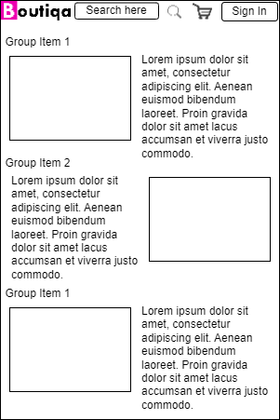

Register Page

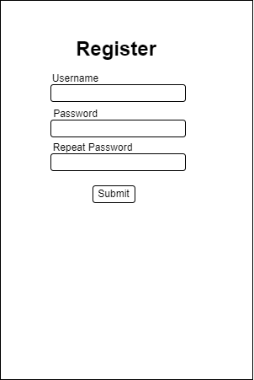

Log in Page

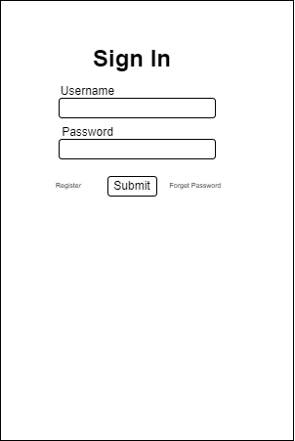

Forget Password Page

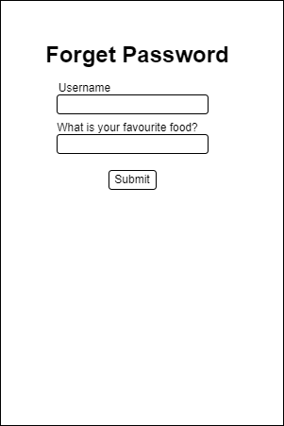

Update profile Page

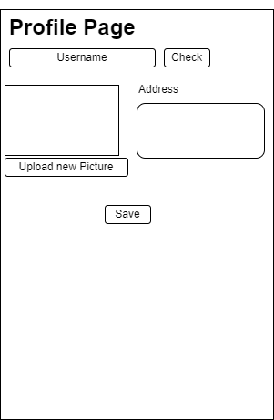

Flow Chart for the solution Architecture

# Task 1 (A1, K1)

## Task Statement:

1. Briefly explain techniques and methods for gathering and analysing user feedback.

The questionnaire consists of 3 parts; Pre-Test, trial Test & Post test.  
The Pre-test checks on the user demography  
The trial test observes the user time to use the website without the questioner interfering the test. Expectations and goals are explained prior the trial test.  
Tester are given the following information:  
Email: user1  
Password:123  
Goal:  
Login -> Key in email and password -> profile page -> edit username ->go main page->   
Search product->add to cart->check out

Pre-Test Questions Sample & Answer

|  |  |  |
| --- | --- | --- |
| No | Questions | Answers |
| 1 | What is your occupation | Architect |
| 2 | How comfortable are you ordering through online? (1 – lowest to 5 – highest) | 5 |
| 3 | What is your expected duration of us from start to finish   1. <30 sec 2. 30sec< time> 1 min 3. 1 min < time > 2 mins 4. >2 mins | 3 |
| 4 | What is your expected budget when visiting a florist?  1)<$15  2) $15< budget >$20  3) $20< budget >$25  4 >$25 | 2 |

Trial run

|  |  |  |
| --- | --- | --- |
| No | Time taken | 2 min 24sec |

Post Test Questions Sample & Answer

|  |  |  |
| --- | --- | --- |
| No | Questions | Answers |
| 1 | How was your overall experience?  (1 – lowest to 5 – highest) | 3 |
| 2 | What did you like most? | The flower collection is pretty nice |
| 3 | Was there anything unsatisfactory? | Finding the profile page took time |
| 4 | How would you recommend to a friend?  (1 – lowest to 5 – highest) | 3 |

1. Find at least 2 websites which are like ecommerce website and visit and use them and record your experiences.

GrabMart

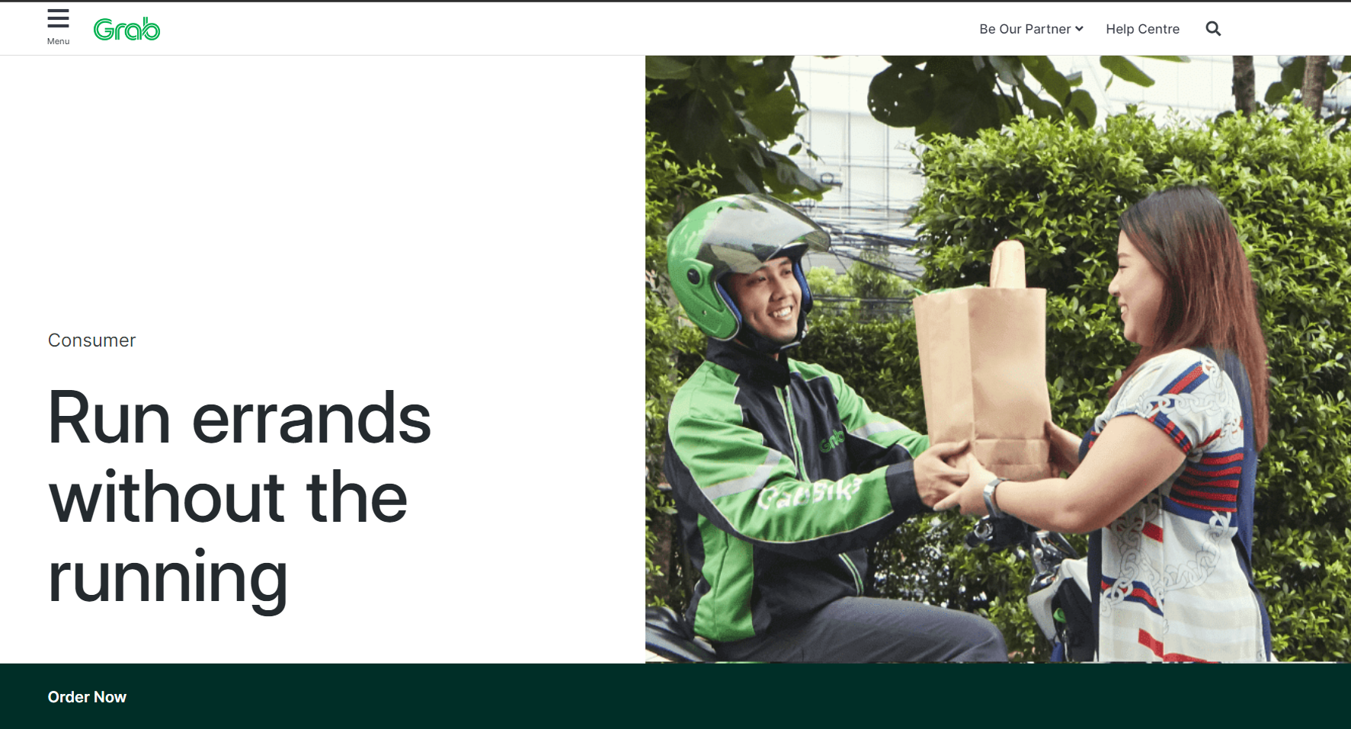

Experience Map:

* Inconvenient way to access the website, too many layers to go through
* Not enough description of items
* Force to download app
* Takes too long to navigate
* Too many words that is not meant for consumer
* Item do not show details of ingredients
* Unable to select schedule to deliver items
* Some pictures not shown

Survey:

What is your occupation

A: Digital Delivery Specialist

How comfortable are you ordering through online?

(1 – lowest to 5 – highest)

A:5

What is your expected duration of us from start to finish

1) <30 sec

2) 30sec< time> 1 min

3) 1 min < time > 2 mins

4) >2 mins

A:3

What is your expected budget when visiting a convenience store?

1)<$15

2) $15< budget >$20

3) $20< budget >$25

4) >$25

A: 1

Time taken: 3mins14secs

How was your overall experience?

(1 – lowest to 5 – highest)

A: 2

What did you like most?

A: I can but basic stationery and non-food items

Was there anything unsatisfactory?

A: navigating the website

How would you recommend to a friend?

(1 – lowest to 5 – highest)

A: 2

Lazada

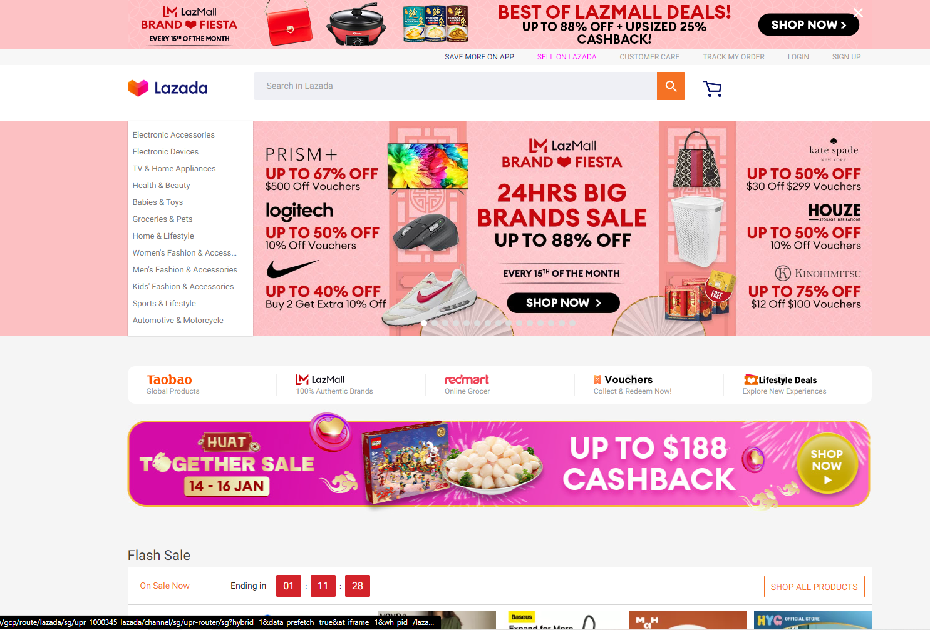

Experience Map:

* Promotions are overwhelming
* Products are categorized well
* Log in is quick
* Similar products and at different prices
* Products is very detailed

Survey:

What is your occupation

A: Modeller

How comfortable are you ordering through online?

(1 – lowest to 5 – highest)

A:5

What is your expected duration of us from start to finish

1) <30 sec

2) 30sec< time> 1 min

3) 1 min < time > 2 mins

4) >2 mins

A:3

What is your expected budget when visiting a convenience store?

1)<$15

2) $15< budget >$20

3) $20< budget >$25

4) >$25

A: 1

Time taken: 3mins14secs

How was your overall experience?

(1 – lowest to 5 – highest)

A: 5

What did you like most?

A: A huge variety of products

Was there anything unsatisfactory?

A: navigating the website

How would you recommend to a friend?

(1 – lowest to 5 – highest)

A: 5

# Task 2 (A2, K2)

## Task Statement:

1. Discuss, study and analyze the user experience based on the observations done in Task 1.
2. Study the experience for 2 to 3 scenarios

## Scenario 1

Log in scenario

GRABMART

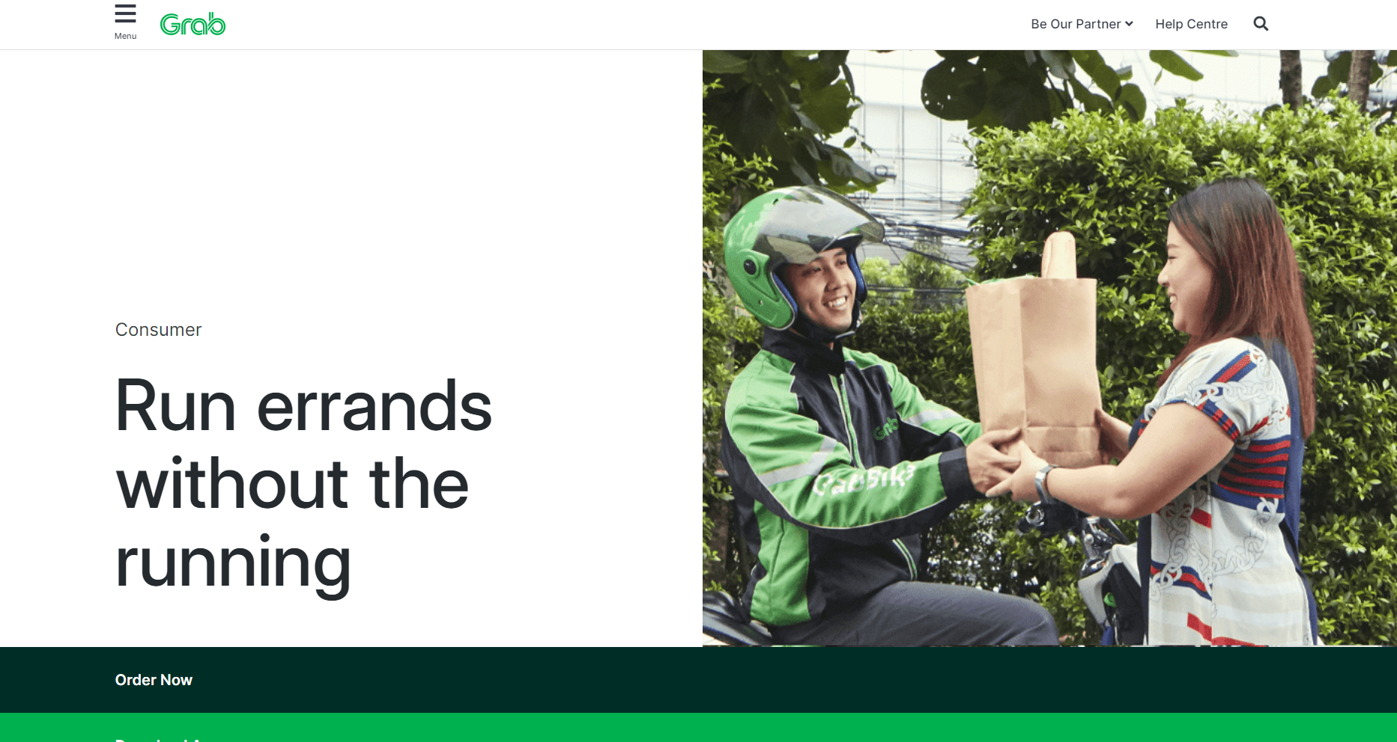

The GrabMart landing page will ask to download the app. Once selected Order now you will proceed to the next page

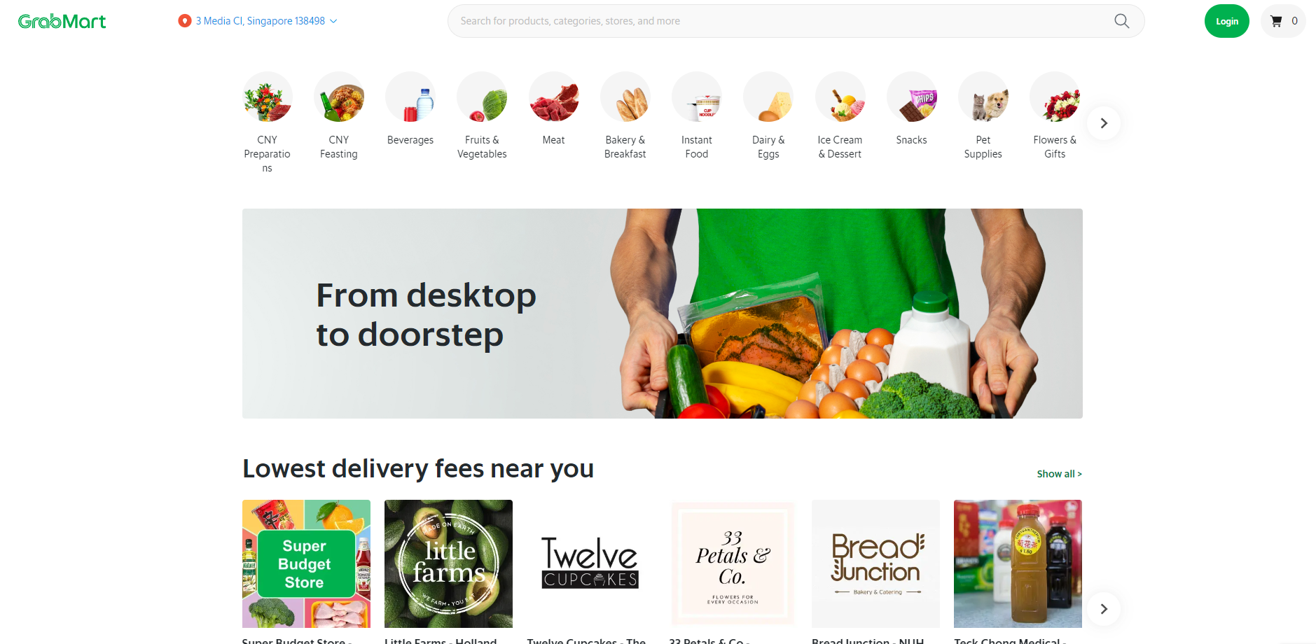

Log in is located at the top right

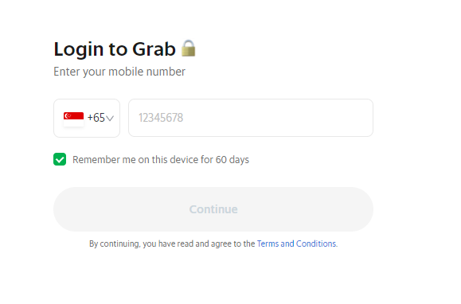 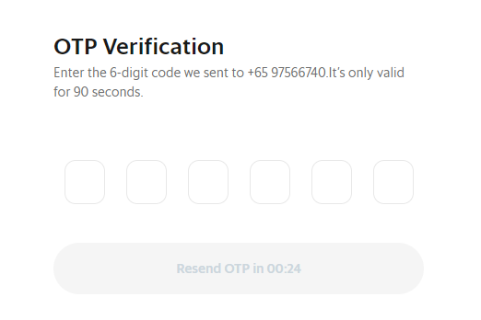

Uses phone number as ID and followed by the pass code

Lazada

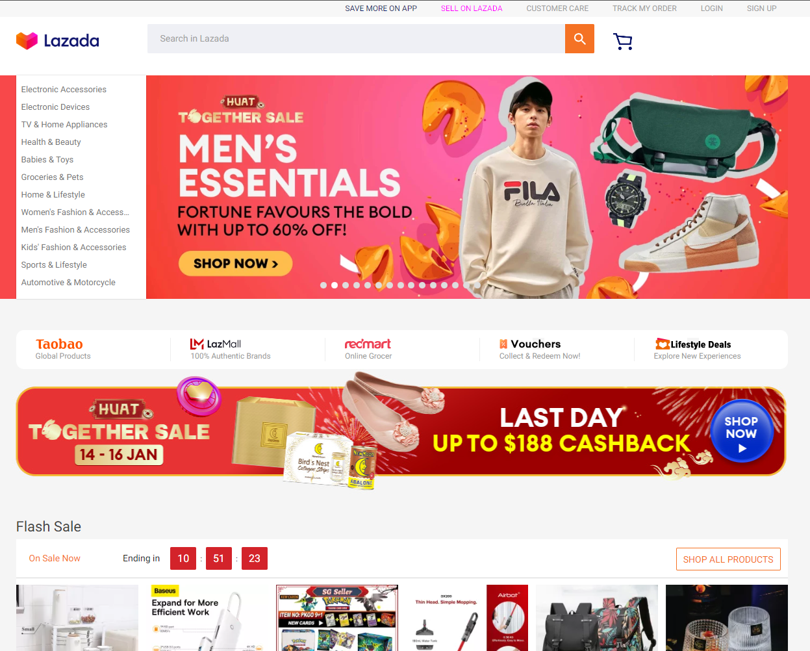

Login is located at the top right

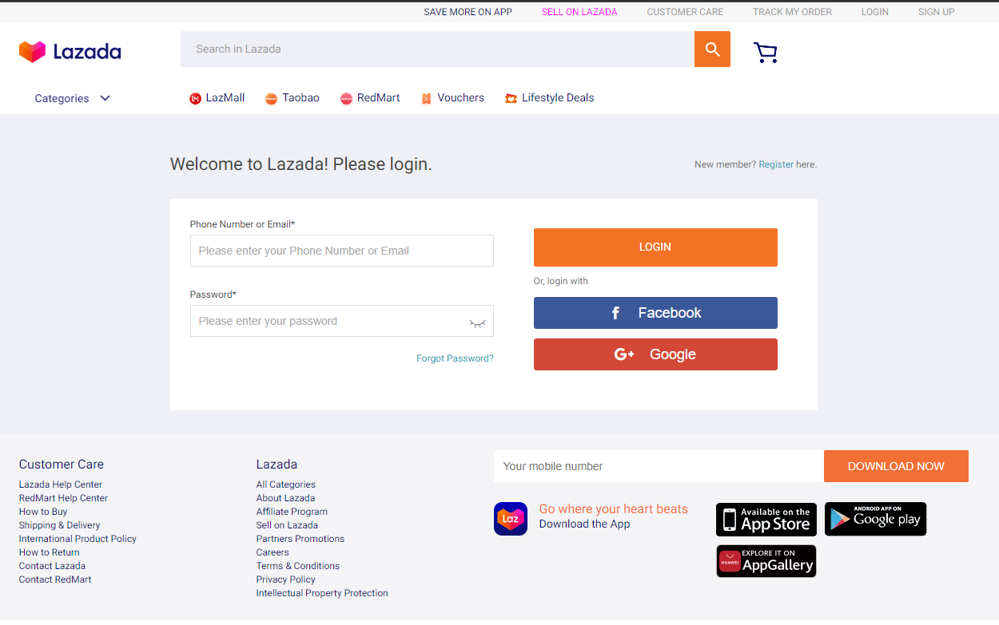

You can use a variety of login methods, and log in immediately

## Scenario 2

GRABMART

Check Out scenario

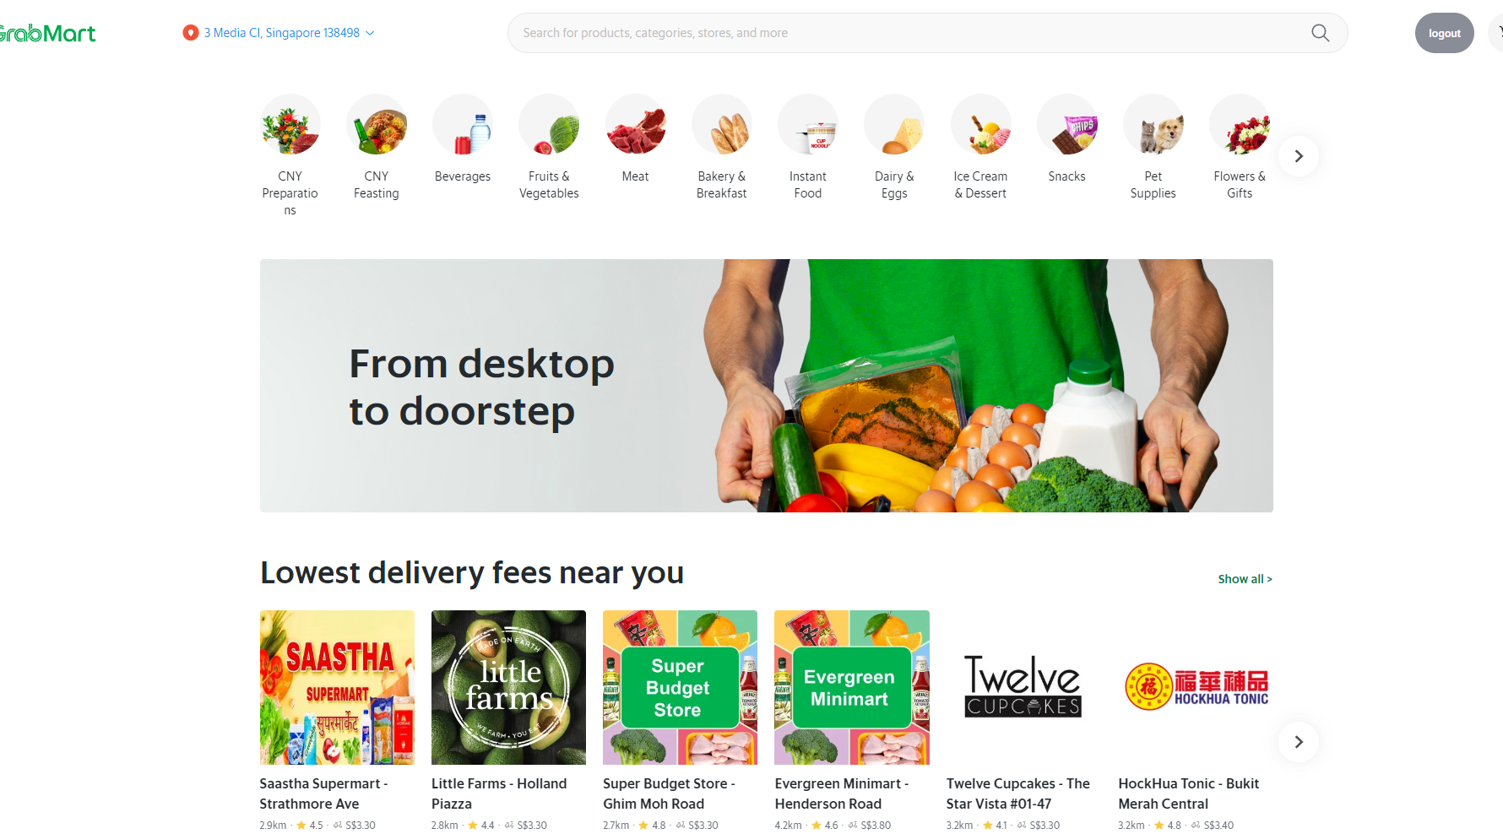

From landing page can select the item you like or from a category or from the search bar

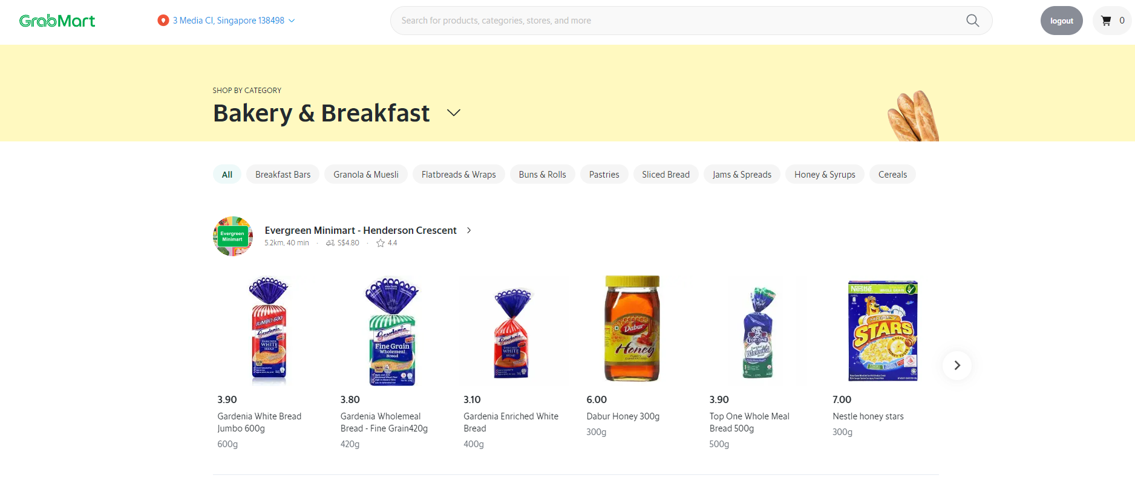

Items can be selected from category

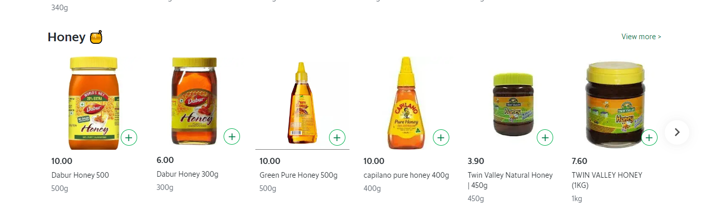

Select the amount of item to buy

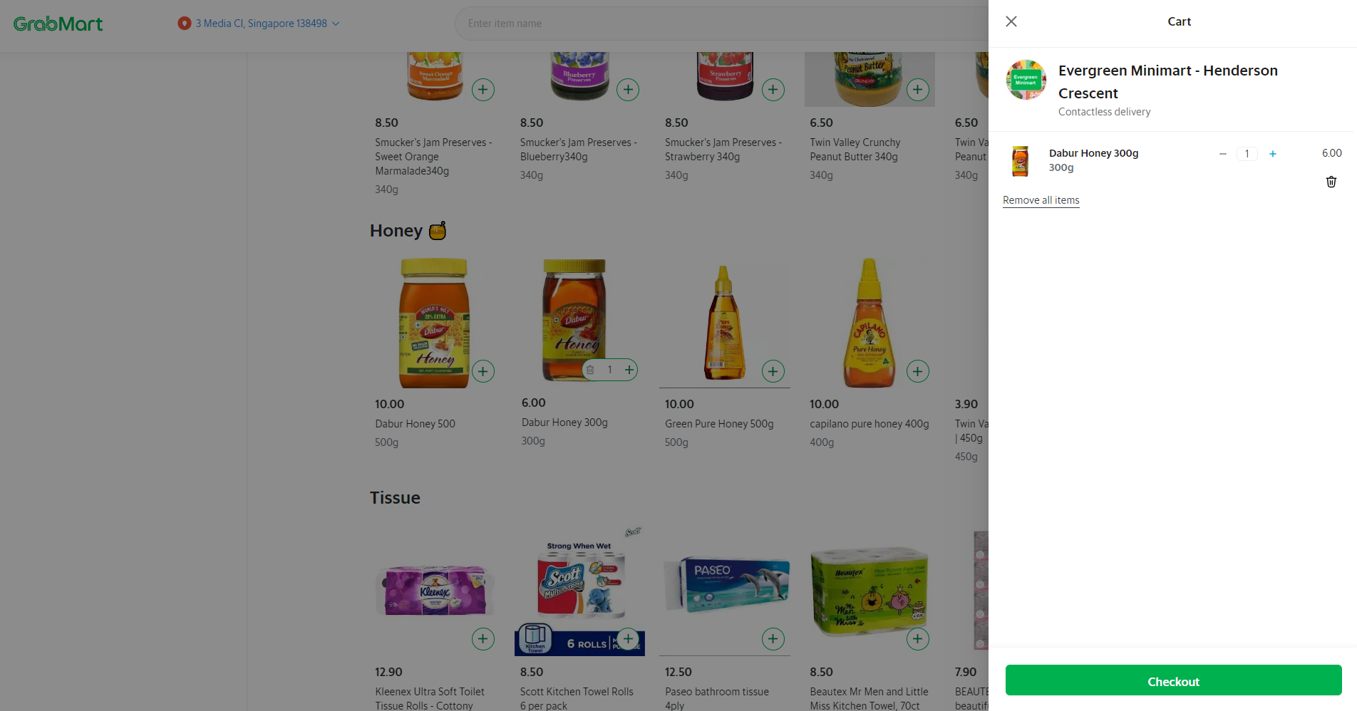

Check out slides from the right panel

Lazada



Lazada you can purchase the item from the various category

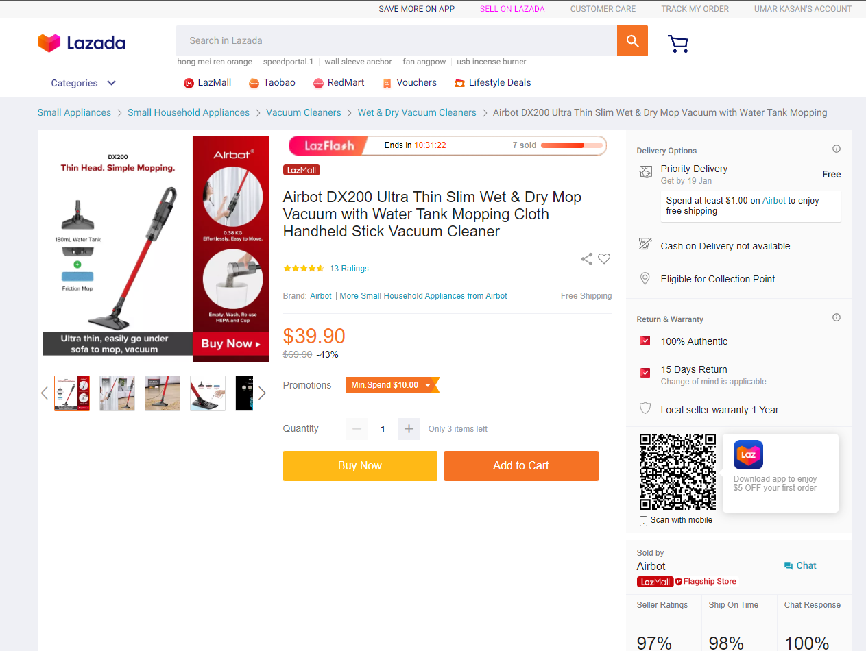

Once item is selected, shows detailed information of the product

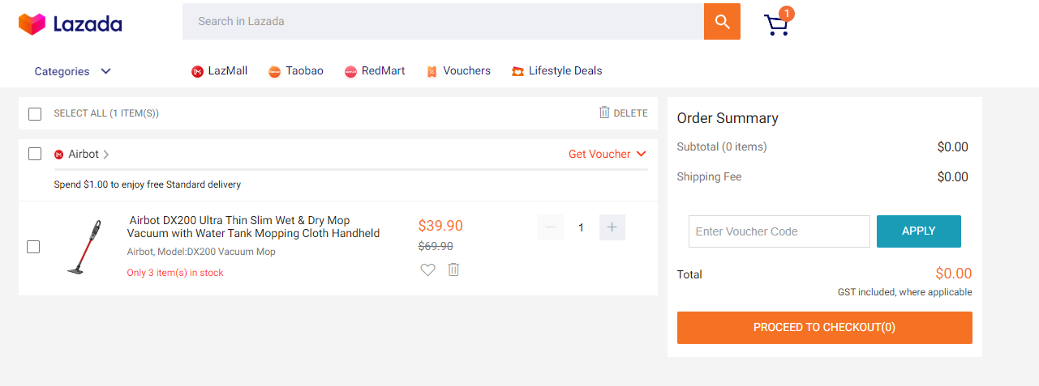

Check out is simple, shows the amount and click check out to check out the item

# Task 3 (A3)

## Task Statement:

1. Identify the performance levels and gaps between user experience in the study & desired user experience.
2. Document it as part of Project Report

Solution:

GRABMART

|  |  |  |  |
| --- | --- | --- | --- |
| Scenario | Expected Completion Time | Actual completion Time | Performance Gap (Actual- Expected) |
| Log In | 30 s | 55 | 55-30=25 |
| Check out | 15 | 45 | 30 |

LAZADA

|  |  |  |  |
| --- | --- | --- | --- |
| Scenario | Expected Completion Time | Actual completion Time | Performance Gap (Actual- Expected) |
| Log In | 30 s | 10 | 10-30=-20 |
| Check out | 15 | 10 | -5 |

# Task 4 (A4)

## Task Statement

1. Develop & document 3 metrics to measure the user experience.
2. TSR: Task Success Rate

5 users are asked to login on both these websites from login->select 1 item (orange: GRABMART & Mop: Lazada)-> Check out

|  |  |  |  |  |  |
| --- | --- | --- | --- | --- | --- |
| Website | User 1 | User 2 | User 3 | User 4 | User 5 |
| GRABMART | 55sec | 65sec | 42sec | 50sec | 75sec |
| Lazada | 35sec | 36sec | 41sec | 37sec | 42sec |

Time on task for Grabmart is : 57.4sec  
Time on task for Lazada is : 38.2sec

1. UER

5 users are asked to login on both these websites from login->key in username/email/phone number->password  
A possible of 3 errors

|  |  |  |  |  |  |
| --- | --- | --- | --- | --- | --- |
| Website | User 1 | User 2 | User 3 | User 4 | User 5 |
| GRABMART | 0 | 2 | 1 | 0 | 0 |
| Lazada | 0 | 0 | 0 | 0 | 0 |

Time on task for Grabmart is : 33% error rate  
Time on task for Lazada is : 0% error rate

1. NPS

From a survey done (1 ~ 6 : detractors, 7~8: Passive, 9~10 Promoter)

|  |  |  |  |  |  |
| --- | --- | --- | --- | --- | --- |
| Website | User 1 | User 2 | User 3 | User 4 | User 5 |
| GRABMART | 6 | 4 | 7 | 6 | 10 |
| Lazada | 8 | 10 | 10 | 8 | 9 |

Net Promoter score for Grabmart is : -40% score  
Net Promoter score for Lazada is : 60% score

Solution

The significant problem with Grabmart was the use of passcode which confused users on password and number types pin code.  
To reduce the error we could apply log in using social media

# Task 5 (K3, K4)

## Task Statement

1. Create the steps in User Interaction process for various scenario.

The questionnaire consists of 3 parts; Pre-Test, trial Test & Post test.  
The Pre-test checks on the user demography  
The trial test observes the user time to use the website without the questioner interfering the test. Expectations and goals are explained prior the trial test.  
Tester are given the following information:  
Email: user1  
Password:123  
Goal:  
Login -> Key in email and password -> profile page -> edit username ->go main page->

Pre-Test Questions Sample & Answer

|  |  |  |
| --- | --- | --- |
| No | Questions | Answers |
| 1 | What is your occupation | Architect |
| 2 | How comfortable are you ordering through online? (1 – lowest to 5 – highest) | 5 |
| 3 | What is your expected duration of us from start to finish   1. <30 sec 2. 30sec< time> 1 min 3. 1 min < time > 2 mins 4. >2 mins | 3 |
| 4 | What is your expected budget when visiting a florist?  1)<$15  2) $15< budget >$20  3) $20< budget >$25  4 >$25 | 2 |

Trial run

|  |  |  |
| --- | --- | --- |
| No | Time taken | 2 min 24sec |

Post Test Questions Sample & Answer

|  |  |  |
| --- | --- | --- |
| No | Questions | Answers |
| 1 | How was your overall experience?  (1 – lowest to 5 – highest) | 3 |
| 2 | What did you like most? | The flower collection is pretty nice |
| 3 | Was there anything unsatisfactory? | Finding the profile page took time |
| 4 | How would you recommend to a friend?  (1 – lowest to 5 – highest) | 3 |

1. Create a flow chart for user interaction.

Scenario Name- Registration

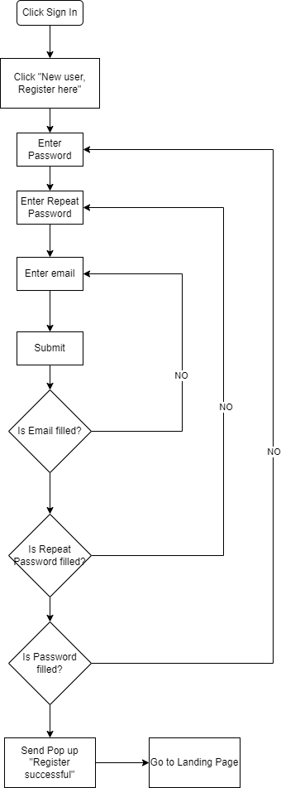

Scenario Name- Log in

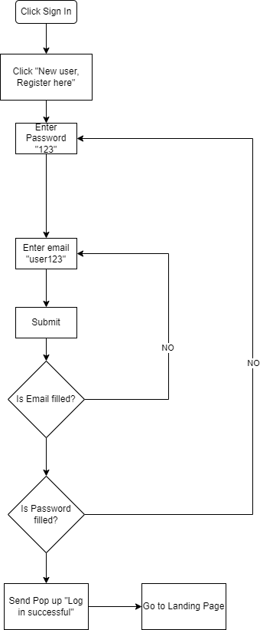

Scenario Name- Forget Password

Scenario Name- Check out

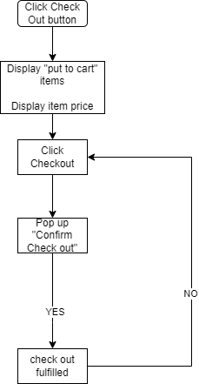

# Task 6 (A5)

## Task Statement:

1. In the Websites study’s get the general user response from one other user.

|  |  |  |  |  |
| --- | --- | --- | --- | --- |
| Scenarios | TOT | UER | NPS | Feedback |
| GrabMart | 57.4 sec | 33% | -40% | Sometimes passcode has issues and unable to log in |
| Lazada | 38.2 sec | 0% | 60% | Untrustworthy sellers |

# Task 7 (A6)

Task Statement

1. Create a Prototype for the proposed system, with at least 5 screens
2. Get the user response and classify them to various types.
3. Screen capture the prototype and include it as part of Project Presentation

Landing Page

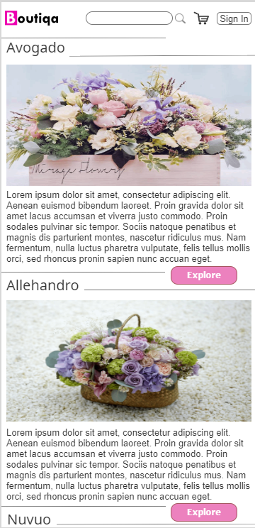

Sign In page  
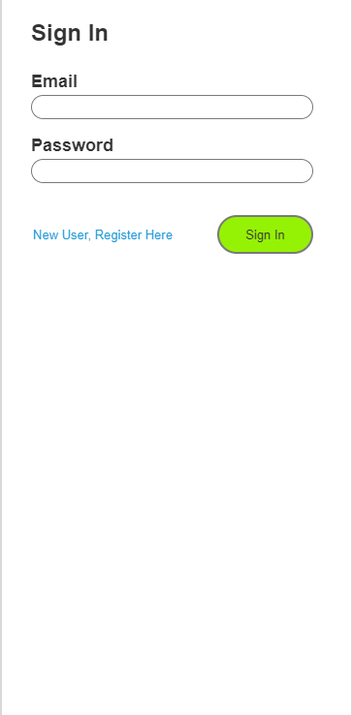

Signed in page  
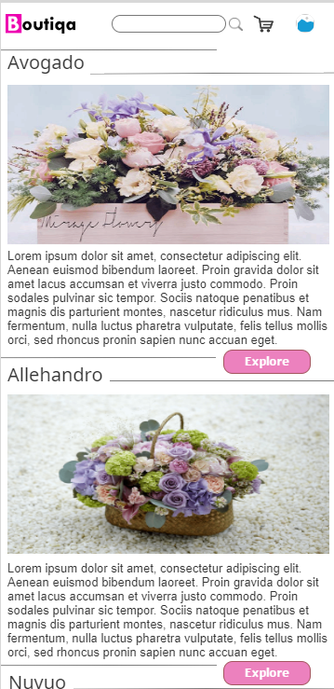

Add to cart

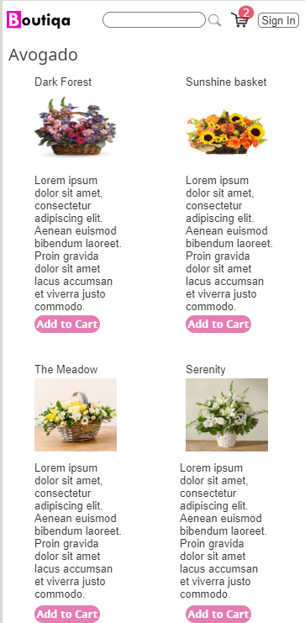

Check out

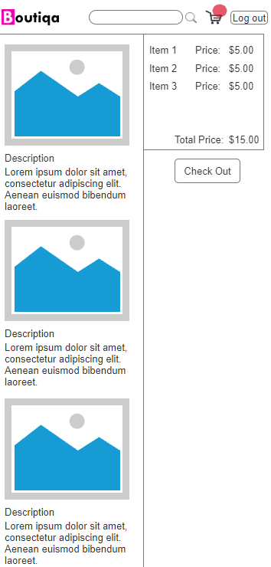

# Task 8 (A7)

Task Statement

1. Demonstrate and let the users give feedback on prototype and document them

Solution

|  |  |  |  |  |  |  |  |  |  |
| --- | --- | --- | --- | --- | --- | --- | --- | --- | --- |
| Users | Question 1 | Question 2 | Question 3 | Question 4 | Question 5 | Question 6 | Question 7 | Question 8 | Question 9 |
| Wei Ting | Architect | 5 | 3 | 2 | 2:24 | 3 | The flower collection is pretty nice | Finding the profile page took time | 3 |
| Sze Yuan | Technical Engineer | 5 | 4 | 1 | 1:15 | 3 | The design is very minimalistic | No delivery option | 4 |
| Harith | BIM Modeller | 5 | 3 | 2 | 1:45 | 4 | The website offer ready made bouquet | NIL | 3 |
| Li Qing | Civil Engineer | 5 | 5 | 3 | 0:59 | 4 | purchasing is simple and quick | Prefer to see categories or filters while searching | 5 |
| Samuel | IT Technician | 5 | 5 | 1 | 1:05 | 5 | Design is very intuitive | nil | 4 |

Improvements:

On feedback of profile page was difficult to find, the design can be improved by adding a “hamburger” menu (≡) icon as it is universally understood that there are more options there.

Users feedback that they prefer to add category items as a banner to easily browse the website, A banner displaying all the category can be shown just below the header before any contents is shown

Another user said that delivery option was not available. Currently there is only 1 delivery option, to resolve this , information on the delivery type will be displayed so the user is informed how its delivered.

# Task 9 (K5, K6, A8)

Task Statement

1. Create 3 Usability tests and execute the usability tests with a user

Solution:

1. User Login

**Before Modification**

|  |  |  |  |  |  |
| --- | --- | --- | --- | --- | --- |
| S/N | Participants | TOT | UER | TSR | Feedback |
| 1 | Wei Ting | 15s | 1 | Success | - |
| 2 | Sze Yuan | 10 | 1 | Success | Password left empty |
| 3 | Harith | 15 | 2 | Success | Accidentally clicking forget password option |
| 4 | Li Qing | 15 | 0 | Success | Password less than 8 characters |
| 5 | Samuel | 20 | 1 | Success | Misstyped password |
| Total or Average | | 15s | 16% | 100% |  |

**After Modification**

|  |  |  |  |  |  |
| --- | --- | --- | --- | --- | --- |
| S/N | Participants | TOT | UER | TSR | Feedback |
| 1 | Wei Ting | 15s | 0 | Success |  |
| 2 | Sze Yuan | 10 | 0 | Success |  |
| 3 | Harith | 15 | 0 | Success |  |
| 4 | Li Qing | 15 | 0 | Success |  |
| 5 | Samuel | 20 | 0 | Success |  |
| Total or Average | | 15s | 100% | 100% | Password validations helps user to enter correct data |

User Registration

**Before Modification**

|  |  |  |  |  |  |
| --- | --- | --- | --- | --- | --- |
| S/N | Participants | TOT | UER | TSR | Feedback |
| 1 | Wei Ting | 35s | 2 | Success | Clear interface |
| 2 | Sze Yuan | 20 | 1 | Success | Password less than 8 characters |
| 3 | Harith | 35 | 4 | Success | Password doesn't mention any validation on how many digits needed |
| 4 | Li Qing | 30 | 1 | Success | Password less than 8 characters |
| 5 | Samuel | 25 | 0 | Success | Password didn't match |
| Total or Average | | 30s | 36% | 100% |  |

**After Modification**

|  |  |  |  |  |  |
| --- | --- | --- | --- | --- | --- |
| S/N | Participants | TOT | UER | TSR | Feedback |
| 1 | Wei Ting | 35s | 0 | Success |  |
| 2 | Sze Yuan | 20 | 0 | Success |  |
| 3 | Harith | 35 | 0 | Success |  |
| 4 | Li Qing | 30 | 0 | Success |  |
| 5 | Samuel | 25 | 0 | Success |  |
| Total or Average | | 30s | 100% | 100% | Password validations helps user to enter correct data |

Check Out

**Before Modification**

|  |  |  |  |  |  |
| --- | --- | --- | --- | --- | --- |
| S/N | Participants | TOT | UER | TSR | Feedback |
| 1 | Wei Ting | 35s | 2 | Success | Expecting delivery option |
| 2 | Sze Yuan | 20 | 1 | Success | Delivery cost not indicated |
| 3 | Harith | 35 | 4 | Success |  |
| 4 | Li Qing | 30 | 1 | Success |  |
| 5 | Samuel | 25 | 0 | Success |  |
| Total or Average | | 30s | 36% | 100% |  |

**After Modification**

|  |  |  |  |  |  |
| --- | --- | --- | --- | --- | --- |
| S/N | Participants | TOT | UER | TSR | Feedback |
| 1 | Peter | 35s | 0 | Success |  |
| 2 | Bonnie | 20 | 0 | Success |  |
| 3 | Aaron | 35 | 0 | Success |  |
| 4 | Fanny | 30 | 0 | Success |  |
| 5 | Mike | 25 | 0 | Success |  |
| Total or Average | | 30s | 100% | 100% | Information of delivery price and information helps manage expectations |